# Seatime – Ship & Crew

Contents

Seatime – Ship & Crew 1

Purpose 1

Setup 1

Ship Name 1

Report Year 1

Crew 2

Ship Status 2

Crew Leave Type 3

Data Entry 3

Ship Data 3

Crew Data 4

Report 4

Help 5

## Purpose

This document is the User Manual for the Excel application “Seatime – Ship & Crew”.

This application allows you to record what activity the ship was doing throughout the year and when each crew member was on leave. Based on this information a calendar year at a time tabular report, complete with summaries, can be produced at the press of a button for the ship and each crew member.

Three main worksheets are used, “Overview”, “Ship Data” and “Crew Data”. An extra worksheet is created for each yearly report.

Initial setup is required for the Crew details. After this all that is required is to record what activity the ship is doing and when each crew member is on leave. A report can then be produced on request.

## Setup

Initial setup is done in the “Overview” worksheet.

### Ship Name

The ship name should be typed into cell “B3”.

### Report Year

The year for which you would like to produce a report is typed into cell “C5”. This can be changed as often as you like. Each time the “Run Report” button is pressed a report is processed. The first time a report is run for a year, a new worksheet is created titled “YYYY Report” where “YYYY” is the year. When “Run Report” is rerun for a year, the existing worksheet is updated.

### Crew

Crew details are set up using the portion of the “Overview” worksheet shown below:

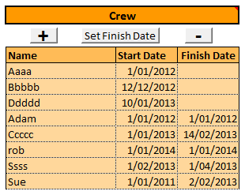To add a new Crew member click the button under the Crew cell. A pop-up box will be shown to enter the crew member’s name. Enter their name and click Ok. Another pop-up box will be displayed to enter the crew member’s start date. Enter their start date and click Ok. Their name will then be added to the list. The list is sorted alphabetically. All crew members with a finish date entered are moved to the bottom of the list.

The name specified here are used when entering the Crew Data and in producing the report. The start date is used to produce the report to ensure information is only reported for each crew member once they have started.

When a crew member leaves the ship select their name and click the  button to enter the date the crew member left. This will ensure the report only reports on the duration the crew member was with the ship.

To remove a crew member from the list completely, select their name and click the  button.

This list of crew names is used to populate a drop down list on the “Crew Data” worksheet. The report only reports on crew members in this list and only when the start and finish dates include the whole or part of the year the report is for.

### Ship Status

Ship statuses are used to distinguish different activities and are set up using the portion of the “Overview” worksheet shown below:

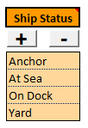 To add a new ship status click the button under the Ship Status cell. A pop-up box will be shown to enter the ship status. Enter the ship status and click Ok. The ship status will then be added to the list. The list is sorted alphabetically.

To remove a ship status from the list completely, select the ship status and click the  button.

This list of ship statuses is used to populate a drop down list on the “Ship Data” worksheet and on the report.

### Crew Leave Type

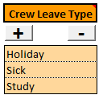Crew Leave Types are set up using the portion of the “Overview” worksheet shown below:

To add a new crew leave type click the button under the Crew Leave Type cell. A pop-up box will be shown to enter the crew leave type. Enter the crew leave type and click Ok. The crew leave type will then be added to the list. The list is sorted alphabetically.

To remove a crew leave type from the list completely, select the crew leave type and click the  button.

This list of crew leave types is used to populate a drop down list on the “Crew Data” worksheet and on the report.

## Data Entry

Ongoing data entry consists of keeping the “Ship Data” and “Crew Data” worksheets up to date.

### Ship Data

Below is a sample of the “Ship Data” worksheet which is used to record the ships activities:

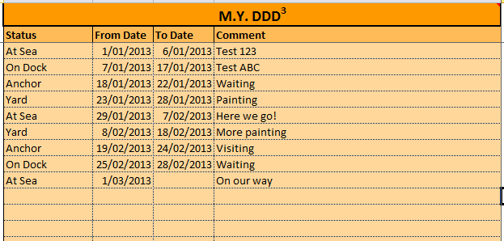

Whenever the “Status” of the ship changes, this spreadsheet should be updated, as follows:

1. Enter the last day of the current activity in the “To Date” in the last row
2. Enter or update the “Comment” for the last row
3. Start a new row by selecting the “Status” from the drop down list in the “Status” column
4. Enter the first day of the new activity in the “From Date”. This should be the day after the “To Date” entered in point 1 above

When the “To Date” of the last activity is left blank, the report will use the date the report is run on as the “To Date”.

### Crew Data

Below is a sample of the “Crew Data” worksheet:

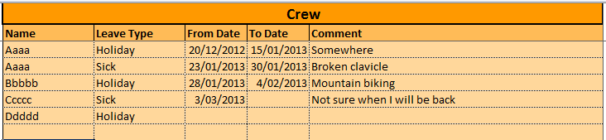

Whenever a crew member goes on leave, this spreadsheet should be updated, as follows:

1. Start a new row by selecting the “Name” from the drop down list in the “Name” column
2. Enter the type of leave by selecting the “Leave Type” from the drop down list in the “Leave Type” column.
3. Enter the first day of the leave in the “From Date” column
4. Enter the last day of the leave in the “To Date” column
5. Enter a note in the “Comment” column if needed

## Report

To create or update a report use the “Overview” worksheet. Check the “Report Year” is the one required and then click the  button.

After a few seconds the report will be complete. Select the worksheet for the desired year.

The first page of the report is for the ship and shows what activity the ship was doing for each day of the year. A summary for the ship is included.

Each page following is for a different crew member showing what they were doing. The periods of leave are highlighted. A summary for each crew member is included.

## Help

For any further assistance or enhancements contact Rob Bebbington by email [rob.bebbington@outlook.com](mailto:rob.bebbington@outlook.com)